Topic – 3
Experiments

1. Aim
To implement the Brute Force String Matching algorithm to find the first occurrence of a given pattern in a text and display the position along with the number of character comparisons.

Algorithm
- Start.
- Read the text and the pattern.
- Set the comparison count to 0.
- Compare the pattern with the text from the first character.
- If characters match, continue comparing the remaining characters.
- Increment the comparison count for every character comparison.
- If the entire pattern matches, display the first occurrence position and comparison count, then stop.
- Otherwise, shift the pattern by one position and repeat the process.
- If the pattern is not found, display "Pattern not found."
- Stop.
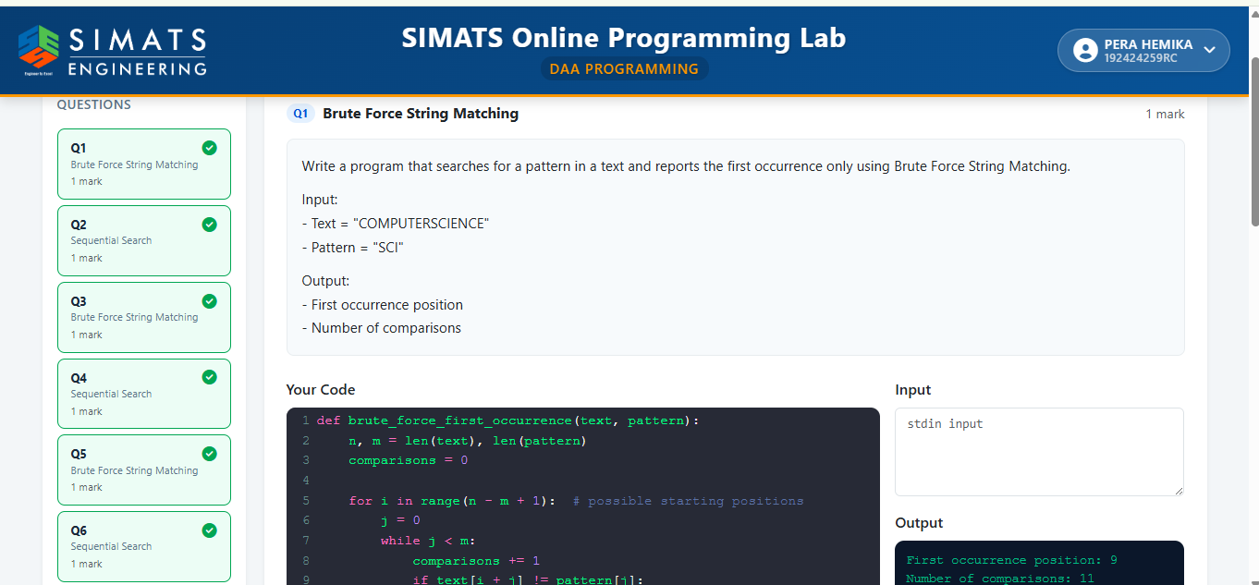

Result
The Brute Force String Matching algorithm was successfully implemented. The first occurrence of the pattern "SCI" in the text "COMPUTERSCIENCE" was found at position 9, and the total number of character comparisons was displayed successfully.

2. Aim
To implement the Sequential Search algorithm to perform an unsuccessful search in an array and display whether the key is found along with the number of comparisons.

Algorithm
- Start.
- Initialize the array and the search key.
- Set the comparison count to 0.
- Traverse the array from the first element to the last.
- Increment the comparison count for each element checked.
- If the current element matches the key, display the position and terminate.
- If the end of the array is reached without finding the key, display "Element not found".
- Display the total number of comparisons.
- Stop.
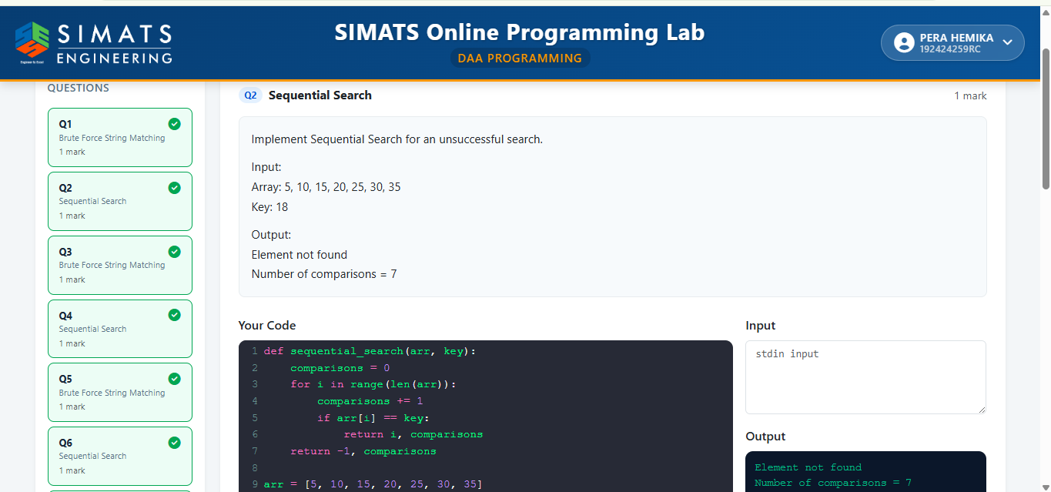

Result
The Sequential Search algorithm was successfully implemented. Since the key 18 is not present in the array {5, 10, 15, 20, 25, 30, 35}, the output displayed "Element not found", and the total number of comparisons = 7.

3. Aim
To implement the Brute Force String Matching algorithm and display the comparison table for each alignment, including the shift number, number of character comparisons, and match/mismatch result.

Algorithm
- Start.
- Read the text and the pattern.
- Calculate the lengths of the text and pattern.
- Align the pattern with the text starting from the first position.
- Compare the characters one by one and count the comparisons.
- If all characters match, record it as a Match; otherwise, record it as a Mismatch.
- Shift the pattern by one position and repeat until all possible alignments are checked.
- Display the shift number, comparisons made, and match/mismatch result for each alignment.
- Stop.

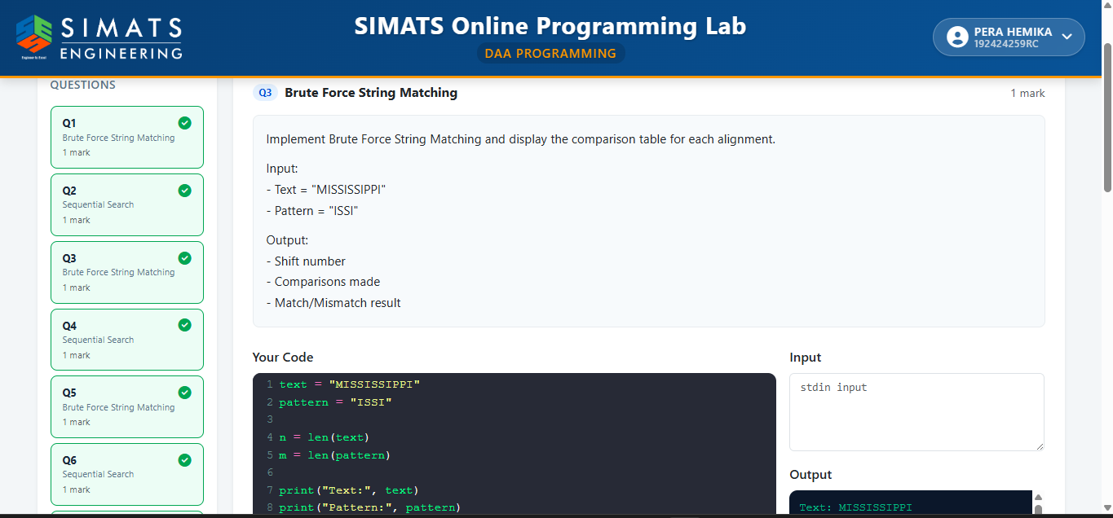

Result
The Brute Force String Matching algorithm was successfully implemented. The comparison table for each alignment was generated, showing the shift number, number of character comparisons, and whether each alignment resulted in a match or mismatch for the pattern "ISSI" in the text "MISSISSIPPI".

4. Aim
To implement the Sequential Search algorithm for string data to search for a given name in a list and display its position.

Algorithm
- Start.
- Store the list of names and the search name.
- Traverse the list from the first element.
- Compare each name with the search name.
- If a match is found, display the position of the name (1-based index) and stop the search.
- If the end of the list is reached without finding the name, display "Name not found".
- Stop.

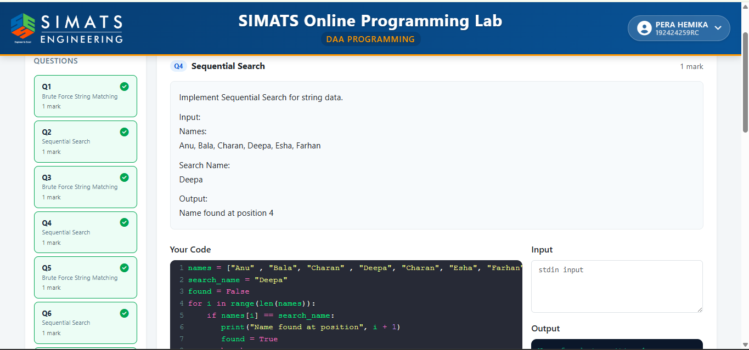

Result
The Sequential Search algorithm was successfully implemented for string data. The search name "Deepa" was found in the list at position 4, and the correct result was displayed.
5. Aim
To implement the Brute Force String Matching algorithm for case-insensitive searching and find the starting position of the given pattern in the text.

Algorithm
- Read the input text and pattern.
- Convert both the text and pattern to lowercase.
- Compare the pattern with each possible substring of the text.
- If all characters match, display the starting position.
- If no match is found, display "Pattern not found".

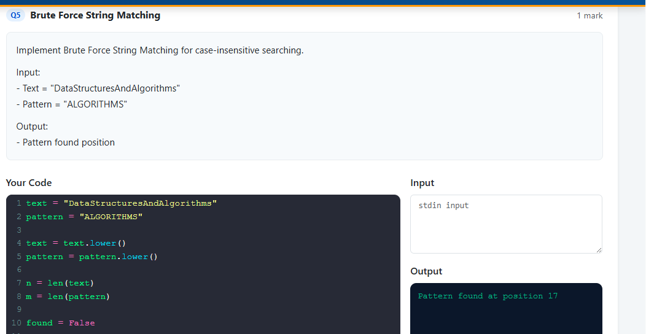

Result
The Brute Force String Matching algorithm was successfully implemented. The pattern "ALGORITHMS" was found in the text at position 18 using case-insensitive matching.
Experiment - 6

Aim
To implement the Sequential Search algorithm, display each comparison, count the number of comparisons for each search key, and analyze its performance.

Algorithm
- Store the given array and search keys.
- For each search key, compare it sequentially with each array element.
- Display every comparison made.
- If the key is found, print its position and the number of comparisons.
- If the key is not found, print "Not Found" and the total comparisons.
- Display the best-case, average-case, worst-case, and space complexities.

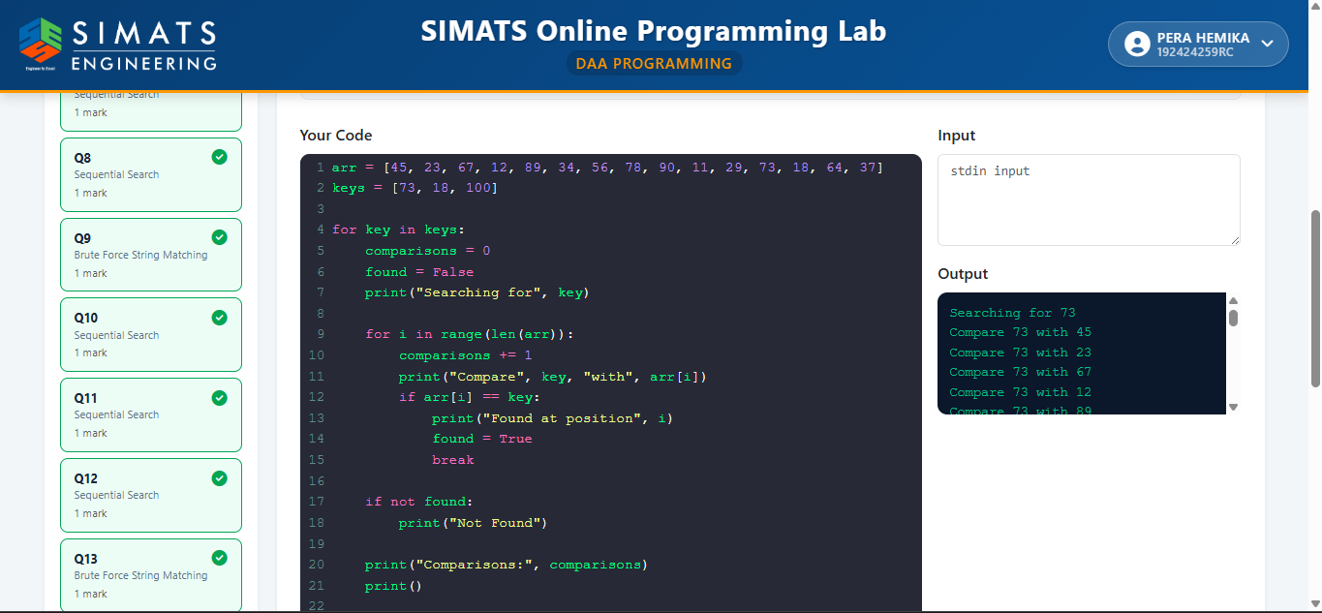

Result
The Sequential Search algorithm was successfully implemented. The search keys were searched one by one, comparisons were counted, positions were displayed for found elements, and the algorithm's time and space complexities were analyzed.

Aim
To implement the Sequential Search algorithm on a 2-D matrix and find the row and column position of the given key.

Algorithm
- Store the given 2-D matrix and the search key.
- Traverse each row and each column of the matrix.
- Compare every element with the search key.
- If the key is found, display its row and column position.
- If the key is not found after checking all elements, display "Element not found".

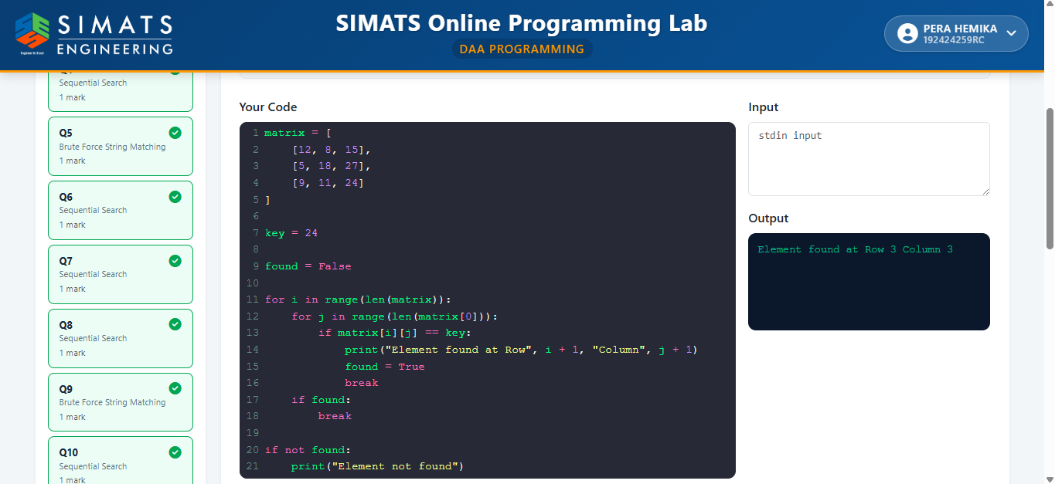

Result
The Sequential Search algorithm was successfully implemented on the given 2-D matrix. The key 24 was found at Row 3, Column 3.

- Aim
To implement the Sentinel Sequential Search algorithm, compare it with ordinary Sequential Search, and determine the position and comparison count of the given key.

Algorithm
- Store the array and search key.
- Save the last element and replace it with the search key (sentinel).
- Compare elements sequentially until the key is found.
- Restore the original last element.
- Display the position and comparison count if the key is found; otherwise, display "Key not found."

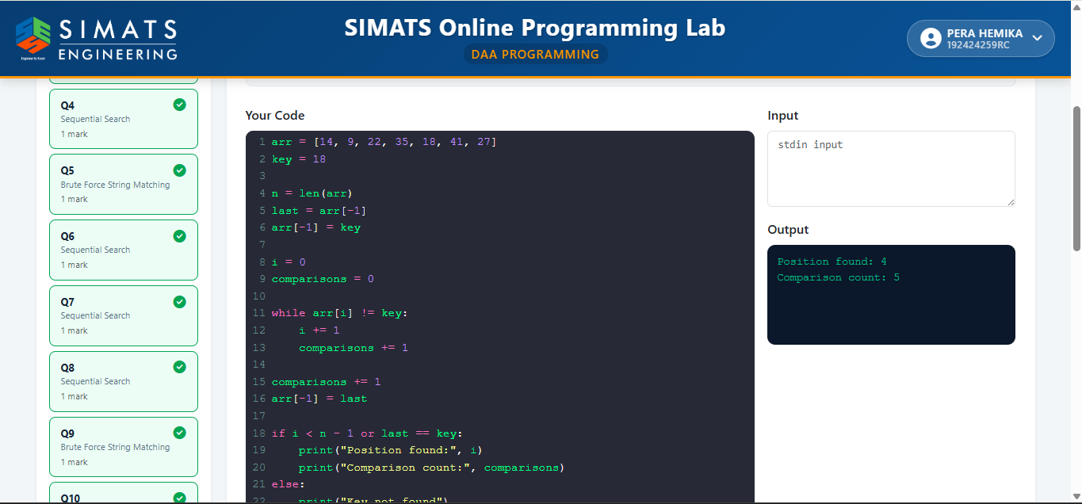

Result
The Sentinel Sequential Search algorithm was successfully implemented. The key 18 was found at position 4 with 5 comparisons, demonstrating fewer boundary checks than ordinary Sequential Search.

Aim
To implement the Brute Force String Matching algorithm, find all occurrences of a pattern in the given text, count the total comparisons, display the shifting process, and analyze its complexity.

Algorithm
- Store the given text and pattern.
- Compare the pattern with every possible position in the text.
- Display the current shift before each comparison.
- If all characters match, record the pattern position.
- Count the total character comparisons.
- Display all matching positions and analyze the best-case, worst-case, and space complexities.

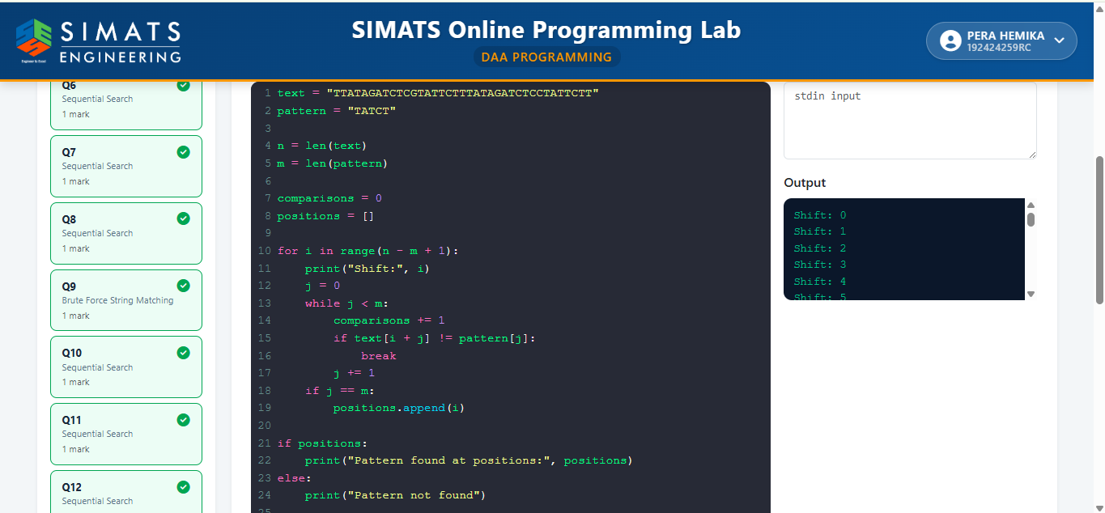

Result
The Brute Force String Matching algorithm was successfully implemented. All occurrences of the pattern were found, the shifting process and total comparisons were displayed, and the algorithm's time and space complexities were analyzed.

10.Aim
To implement the Sequential Search algorithm to find a given element in an array and count the number of comparisons.

Algorithm
- Store the array and the search key.
- Traverse the array from the first element.
- Compare each element with the search key.
- If the key is found, display its position and the number of comparisons.
- If the key is not found, display "Element not found" and the total number of comparisons.

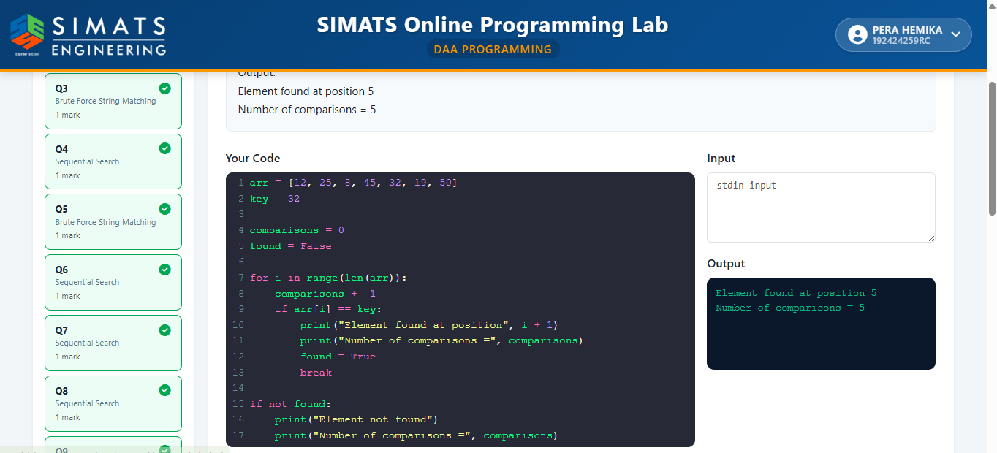Result
The Sequential Search algorithm was successfully implemented. The element 32 was found at position 5 with 5 comparisons.

11. Aim
To implement the Sequential Search algorithm to find the first occurrence of a given element in an array.

Algorithm
- Store the array and the search key.
- Traverse the array from the first element.
- Compare each element with the search key.
- If the key matches, display its first occurrence position and stop the search.
- If the key is not found, display "Element not found".

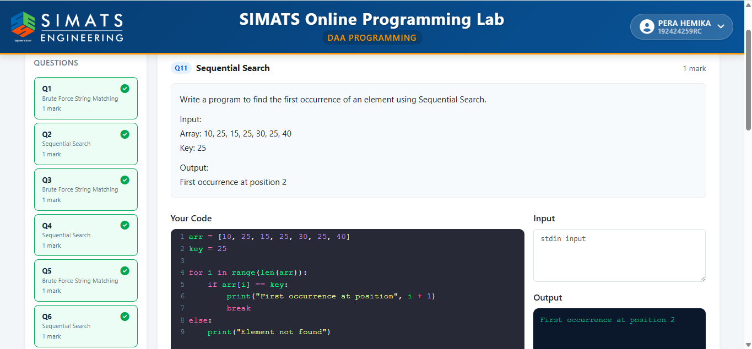Result
The Sequential Search algorithm was successfully implemented. The first occurrence of the
element 25 was found at position 2.

12.Aim
To implement the Sequential Search algorithm and count the total comparisons, total matches, and total mismatches during the search.

Algorithm
- Store the array and the search key.
- Initialize comparison, match, and mismatch counters to zero.
- Traverse the array sequentially.
- Increment the comparison count for each element checked.
- If the key matches, increment the match count and stop the search; otherwise, increment the mismatch count.
- Display the total comparisons, matches, and mismatches.

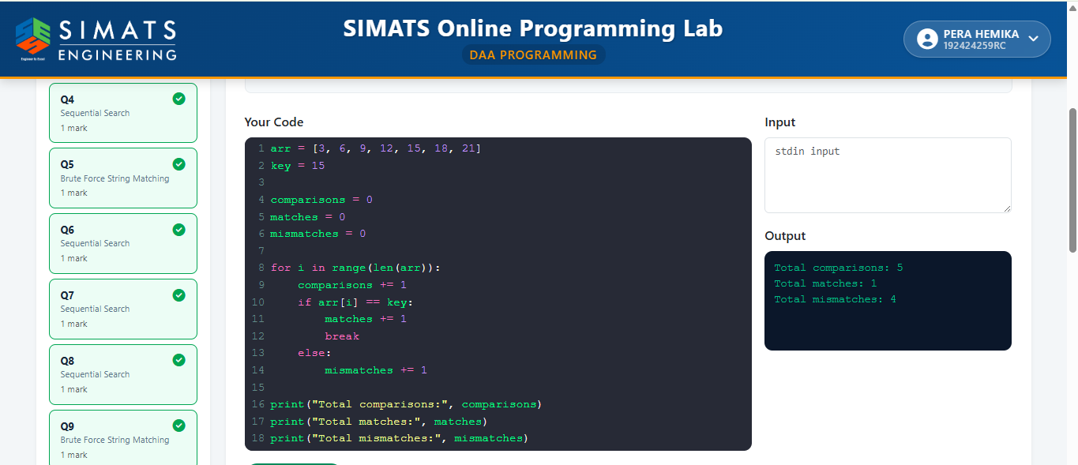

Result
The Sequential Search algorithm was successfully implemented. For the given input, the key 15 was found after 5 comparisons, with 1 match and 4 mismatches.

13.Aim
To implement the Brute Force String Matching algorithm and count the total character comparisons, total matches, and total mismatches during pattern matching.

Algorithm
- Store the given text and pattern.
- Compare the pattern with every possible position in the text.
- Count each character comparison.
- Increment the match count for matching characters and mismatch count for non-matching characters.
- Display the total comparisons, matches, and mismatches.
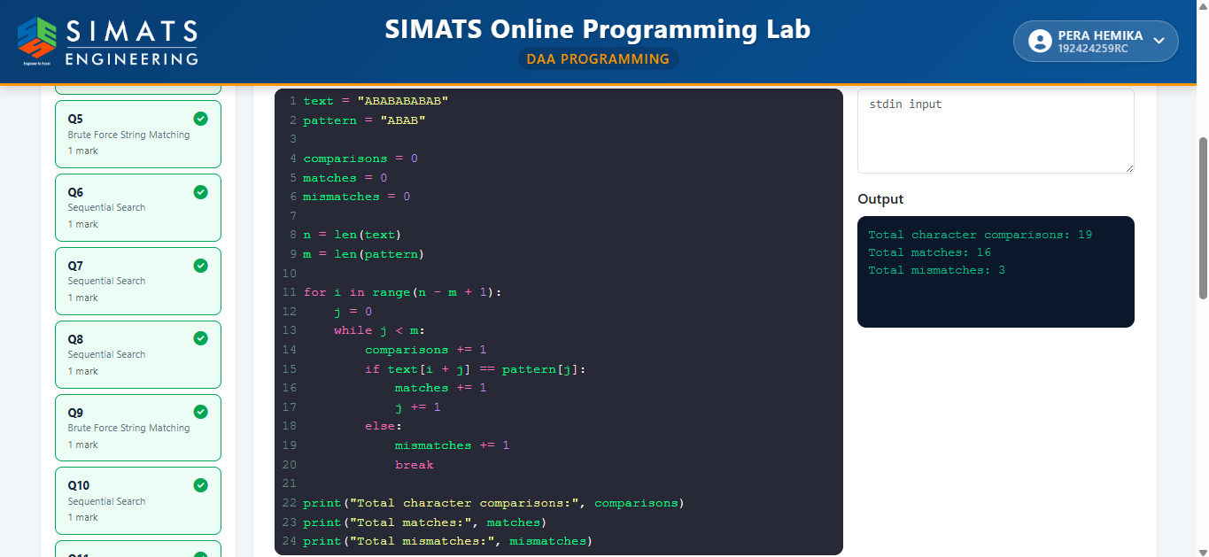

Result
The Brute Force String Matching algorithm was successfully implemented. The total character comparisons, matches, and mismatches were counted and displayed for the given text and pattern.

14.Aim
To implement the Brute Force String Matching algorithm to find all occurrences of a pattern in a given text.

Algorithm
- Store the text and pattern.
- Compare the pattern with every possible position in the text.
- If all characters match, record the position.
- Continue until the end of the text.
- Display all occurrence positions.

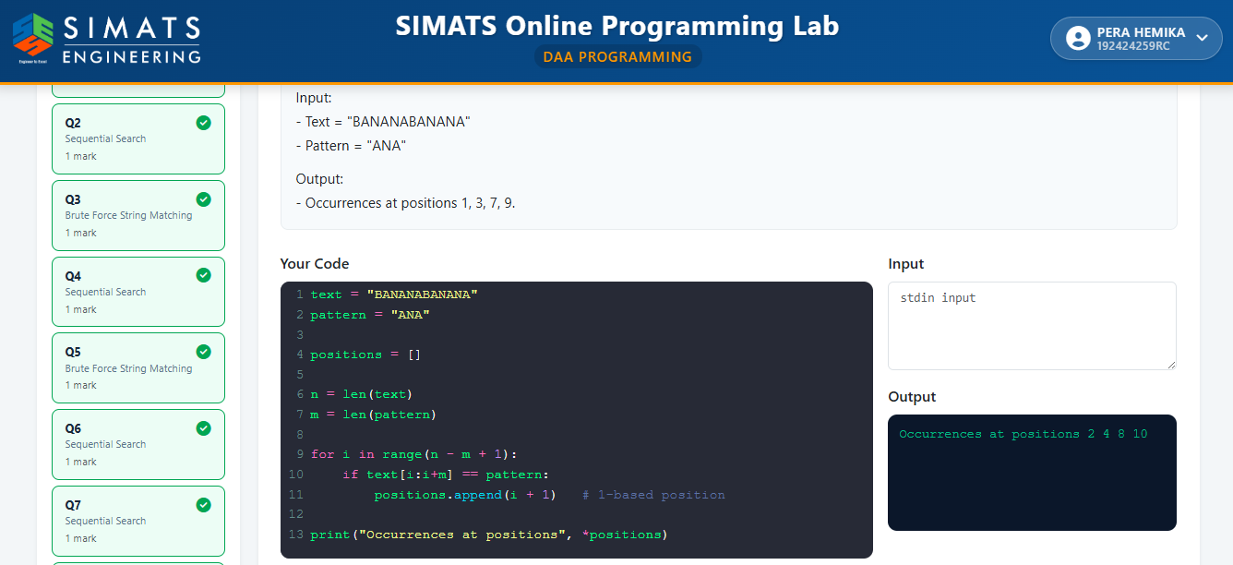Result
The Brute Force String Matching algorithm was successfully implemented, and all occurrences of the pattern in the given text were identified and displayed.

15.Aim
To implement the Sequential Search algorithm to find all occurrences of a given element in an array.

Algorithm
- Store the array and the search key.
- Traverse the array from the first element to the last.
- Compare each element with the search key.
- If a match is found, store its position and increment the occurrence count.
- After completing the search, display all positions and the total number of occurrences.

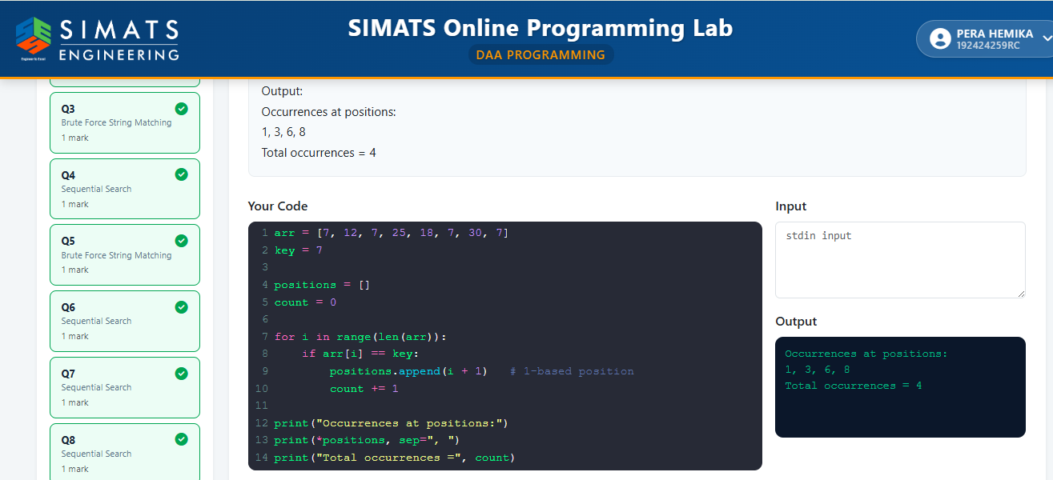Result
The Sequential Search algorithm was successfully implemented. The element 7 was found at positions 1, 3, 6, and 8, with a total of 4 occurrences.

16.Aim
To implement the Brute Force String Matching algorithm, determine the search case (best, average, and worst), and display the number of comparisons performed.

Algorithm
- Store the given text and pattern.
- Compare the pattern with every possible position in the text.
- Count each character comparison.
- If the pattern is found, display its position.
- Display the total number of comparisons and the best, average, and worst-case complexities.

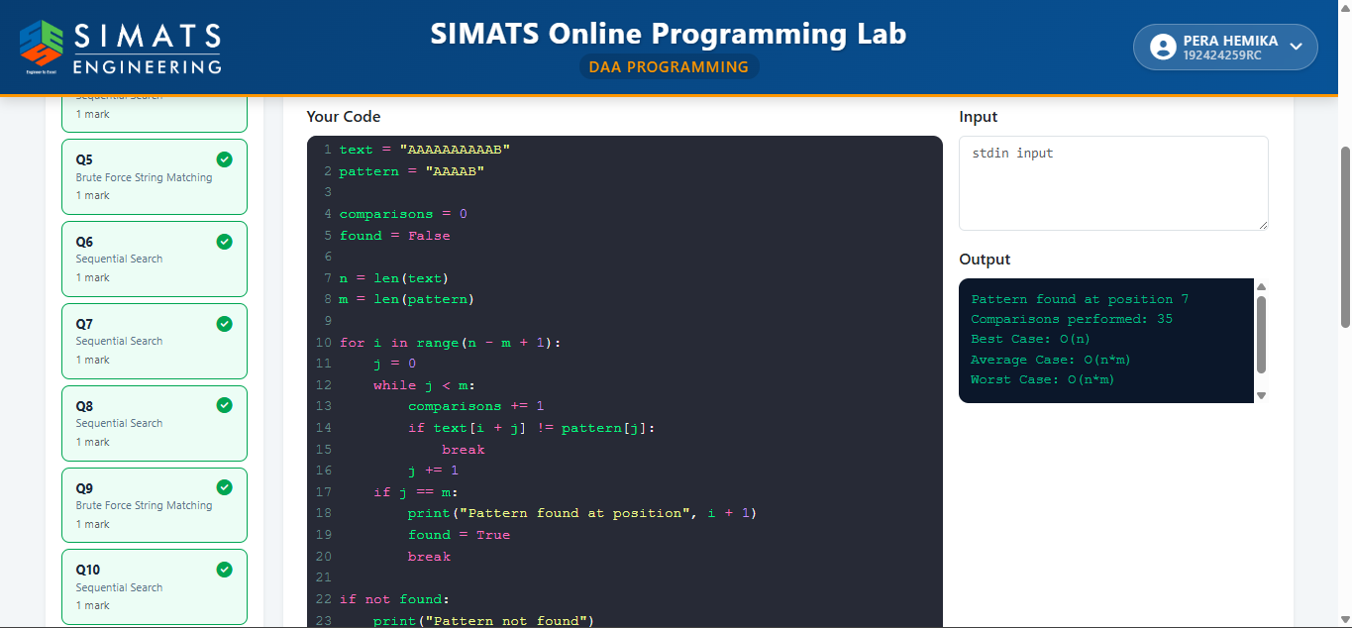Result
The Brute Force String Matching algorithm was successfully implemented. The pattern was found in the given text, the total comparisons were displayed, and the best, average, and worst-case complexities were analyzed.

17.Aim
To implement the Brute Force String Matching algorithm to search for a given pattern in a text, display the position(s) where the pattern occurs, and count the total number of character comparisons.

Algorithm
- Start.
- Read the text and the pattern.
- Calculate the lengths of the text and pattern.
- Align the pattern with the beginning of the text.
- Compare the pattern characters with the corresponding text characters one by one.
- Count each character comparison.
- If all characters match, record the starting position of the pattern.
- Shift the pattern by one position and repeat until all possible alignments are checked.
- Display all matching positions and the total number of comparisons.
- Stop.

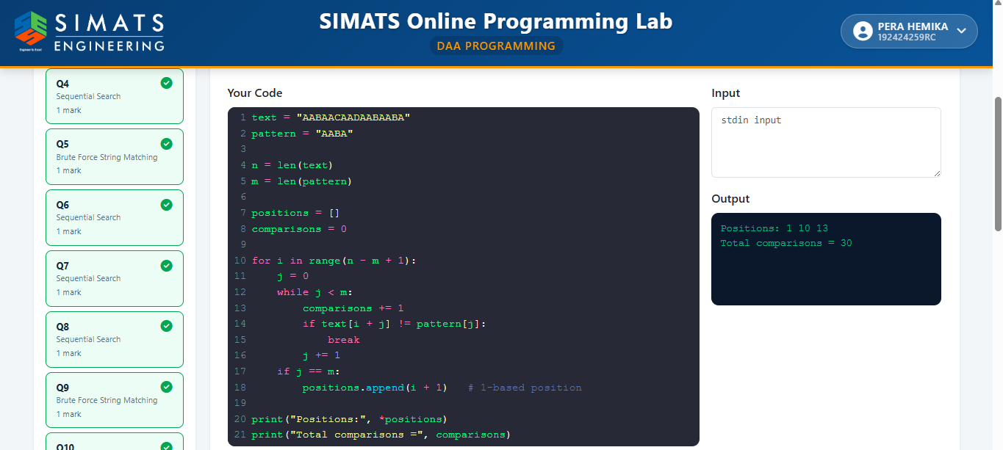

Result
The Brute Force String Matching algorithm was successfully implemented. The pattern occurrences were identified correctly, and the total number of character comparisons was displayed.

18. Aim
To implement the Brute Force String Matching algorithm and compare its execution for successful and unsuccessful searches by displaying the comparison count for both cases.

Algorithm
- Start.
- Read the text and the two patterns.
- For each pattern, align it with the text from the first position.
- Compare characters one by one and count every comparison.
- If all characters match, report a successful search and display the position.
- If no match is found after checking all alignments, report an unsuccessful search.
- Display the total number of comparisons for both successful and unsuccessful searches.
- Stop.
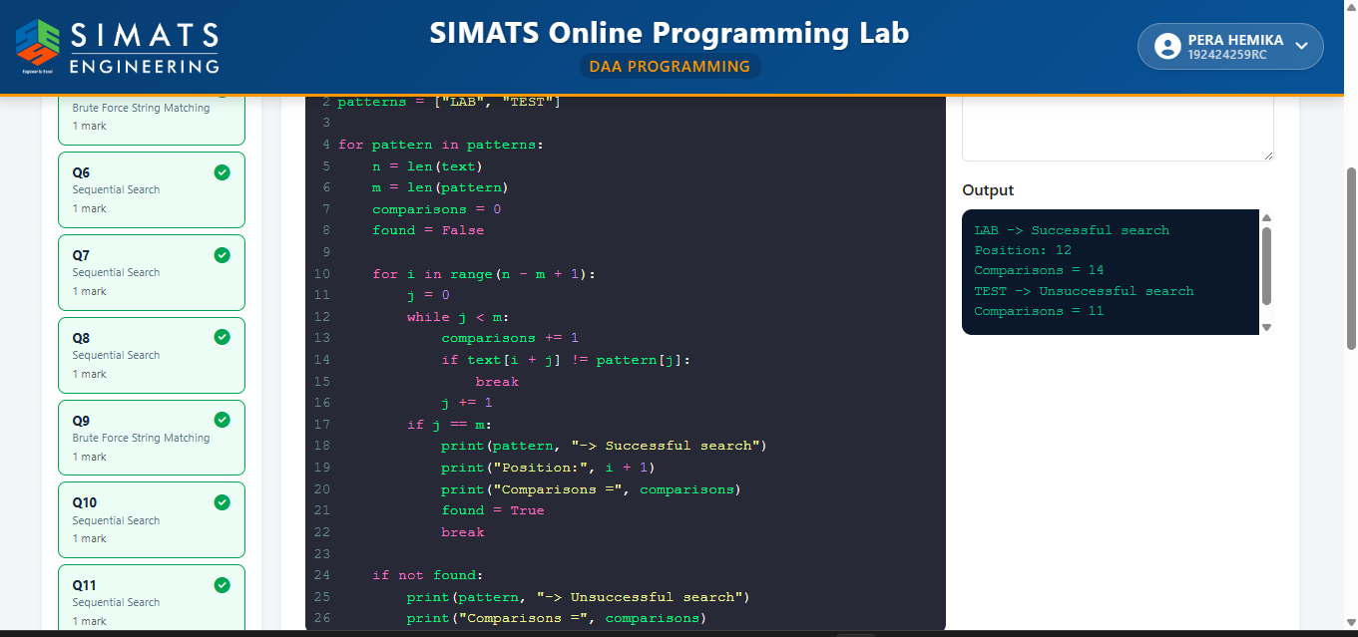

Result
The Brute Force String Matching algorithm was successfully executed for both successful and unsuccessful searches. The program correctly identified whether the pattern was present and displayed the corresponding comparison count for each case.

19. Aim:
To perform Sequential Search on an array of student register numbers and find the position of the given register number.
Algorithm:
- Start.
- Store the register numbers in an array.
- Set the search key.
- Traverse the array from the first element to the last.
- Compare each register number with the search key.
- If a match is found, display the position (index + 1) and stop.
- If the search completes without finding the key, display "Register Number not found."
- Stop.

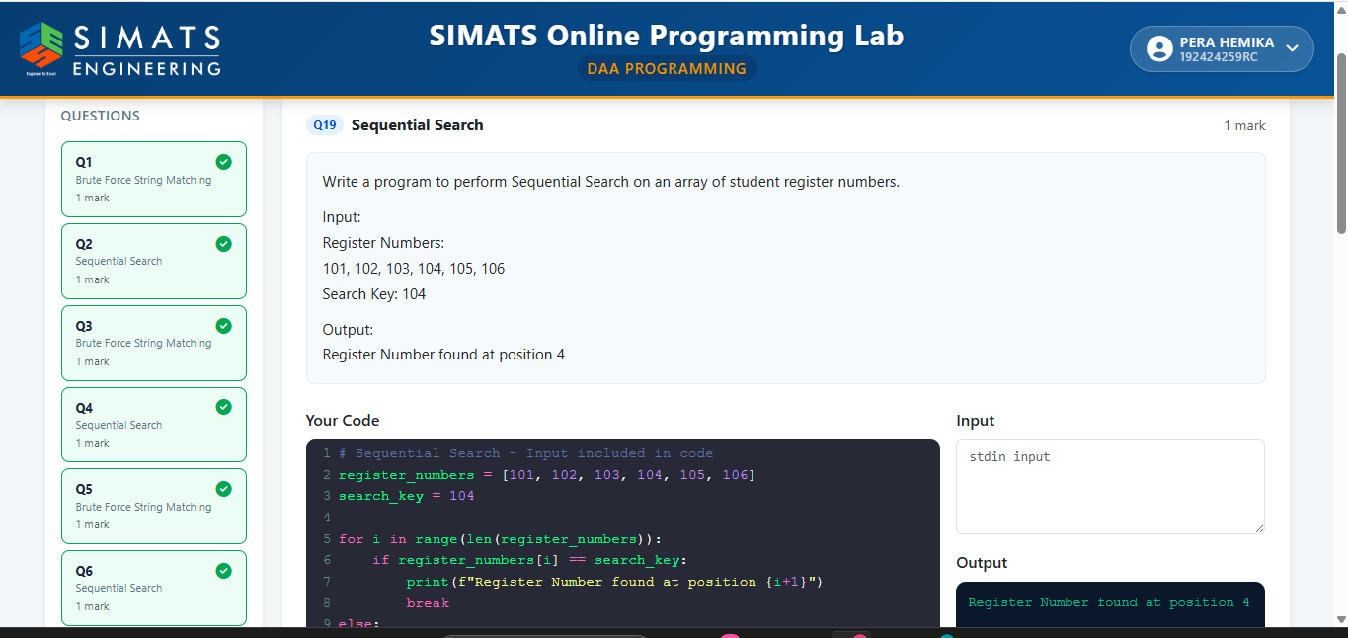
Result:
The Sequential Search was successfully implemented. The register number 104 was found at position 4.

20. Aim
To implement the Brute Force String Matching algorithm to display every alignment of the pattern with the text, identify all matching positions, and report the pattern occurrence positions.

Algorithm
- Start the program.
- Store the given text and pattern.
- Find the lengths of the text (n) and pattern (m).
- Align the pattern at every possible position in the text (0 to n-m).
- Compare each character of the pattern with the corresponding character in the text.
- Display the alignment number and whether it is a Match or Mismatch.
- If all characters match, record the occurrence position.
- Continue until all alignments are checked.
- Display all pattern occurrence positions.
- Stop the program.

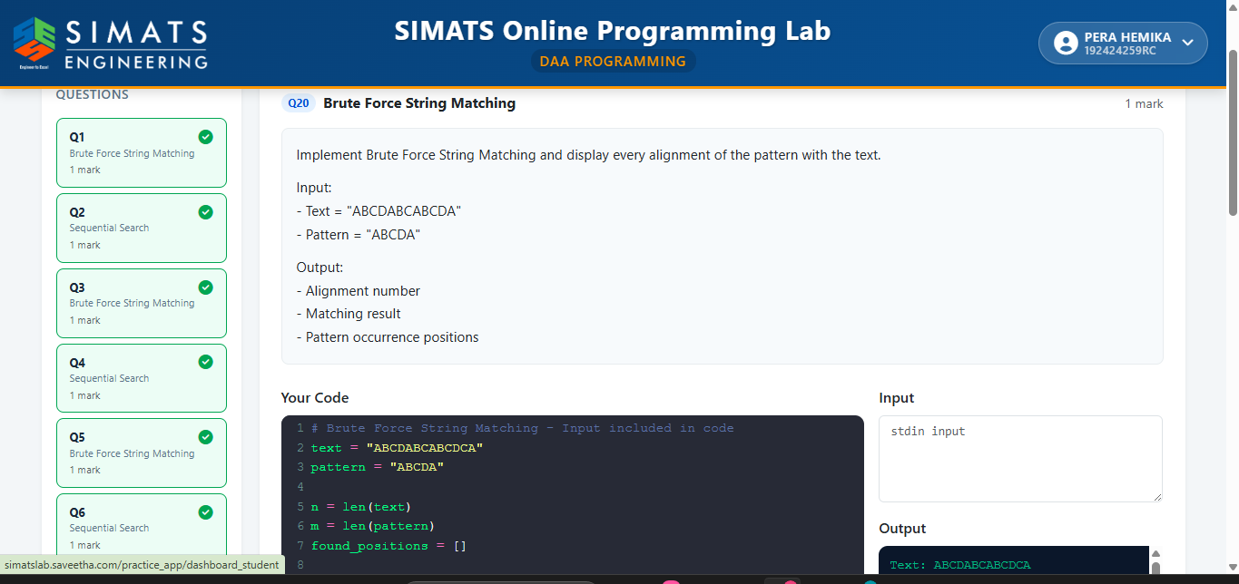

Result
Thus, the Brute Force String Matching algorithm was successfully implemented to display every alignment of the pattern with the text and identify all occurrence positions of the pattern.

